In Class Lab E: Functions

- Practice using functions. Write a C++ program that prompts the user to enter a floating point number (double).

Your code then prints out (call the appropriate functions!)
  - The square root of the number
  - The number raised to the 4th power
  - The floor of the number

- TYPE IN THE FOLLOWING CODE (add a comment that describes the code) AND RUN IT! Submit your output. YOU CANNOT COPY AND PASTE BECAUSE IT IS A PICTURE!

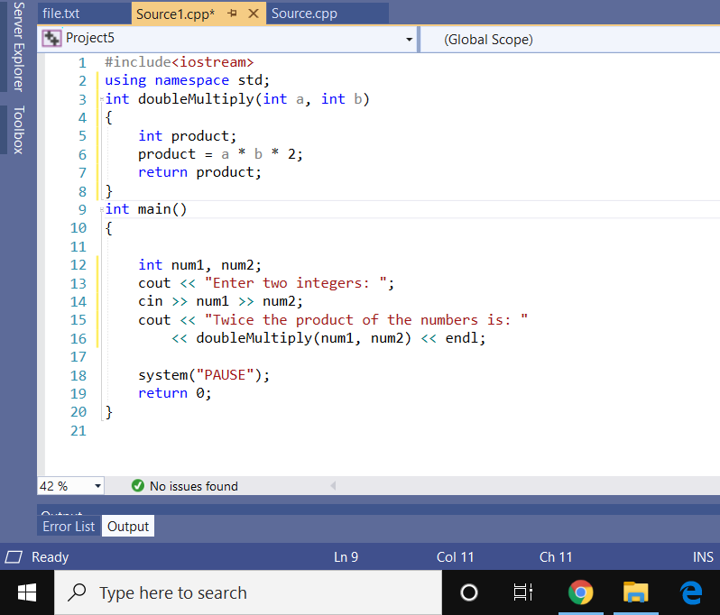

- Write a full program that adds three floating point numbers. Your solution should have a function named getSum that accepts three double parameters and returns the sum of those three doubles.
Your main function should call the getSum function and assigns the return value to a double variable named result that is declared inside the main function.
Your program should then print out the value stored in result. Submit the code and a copy of your output.

